**ASSIGNMENT 1 FRONT SHEET**

|  |  |  |  |
| --- | --- | --- | --- |
| **Qualification** | **BTEC Level 5 HND Diploma in Computing** | | |
| **Unit number and title** | Prog102: Procedural Programming | | |
| **Submission date** |  | **Date Received 1st submission** |  |
| **Re-submission Date** |  | **Date Received 2nd submission** |  |
| **Student Name** | Bùi Hương Linh | **Student ID** | GBH200662 |
| **Class** | GCH1002 | **Assessor name** | Đỗ Tiến Thành |
| **Student declaration**  I certify that the assignment submission is entirely my own work and I fully understand the consequences of plagiarism. I understand that making a false declaration is a form of malpractice. | | | |
|  |  | **Student’s signature** |  |

**Grading grid**

|  |  |  |  |  |  |
| --- | --- | --- | --- | --- | --- |
| P1 | P2 | P3 | M1 | M2 | D1 |
|  |  |  |  |  |  |

|  |  |  |
| --- | --- | --- |
| **❒ Summative Feedback:                                                                 ❒ Resubmission Feedback:** | | |
| **Grade:** | **Assessor Signature:** | **Date:** |
| **Lecturer Signature:** | | |

# 

Contents

Task 1: Programming Language, Procedural Programming. 5

I/ Programming Language: 5

I.1/ Introduction: 5

I.2/ Type of programming language: 6

I.2.1/ Low-level language: 6

I.2.2/ High-level language: 6

II/ Procedural Programming: 6

II.1/ Introduction: 6

II.2/ Characteristies: 7

III/ Problem statement: 8

III.1/ Problem: 8

III.2/ Solution: 8

Task 2: Analysis. 8

I/ List data types and data structures needed in the problem: 8

II/ Switch case statement: 10

III/ If-else statement: 11

IV/ Do-while statement: 11

Task 3: Design 13

I/ Use case: 13

II/ Flowchart: 14

Explain: 16

Explain: 18

Task 4: Evaluation 23

I/ Advantages: 24

II/ Disadvantages: 24

Task 5: Conclution 24

Bibliography 24

# Task 1: Programming Language, Procedural Programming.

## I/ Programming Language:

### I.1/ Introduction:

A programming language is a set of instructions to a computer to execute or a computer language

programmers use to develop software programs.

Currently, there are many programming languages ​​that have been developed to meet the needs of

programmers. This has encouraged many people to study the field of information technology

because of its growing attraction and development.

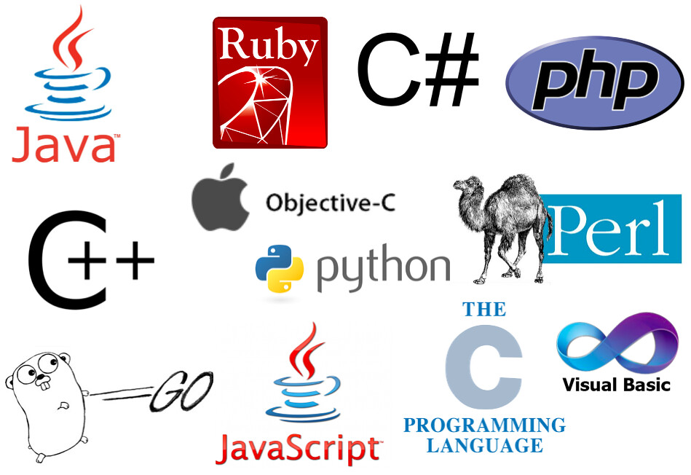

Image 1: Some programming language (source: Internet)

### I.2/ Type of programming language:

### I.2.1/ Low-level language:

A low-level language is a programming language that does not provide abstraction from the hardware and and is more closely related to a computer system.(JavaTpoint,2021)

### I.2.2/ High-level language:

High-level languages are close to human languages, making it easier for people to read and write.(Anthony Grant,2020)

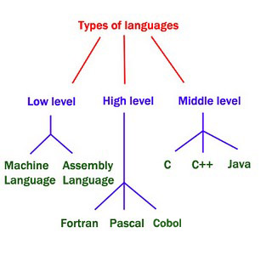

Image 2: Types of programming language(source: Internet)

## II/ Procedural Programming:

### II.1/ Introduction:

Procedural programming (POP) is where the major focus on performing tasks in a sequential order. It divides a large program into small functional blocks or functions for ease of programming and testing easier.(Learn Computer Science,2021)

Example: Using functions find max

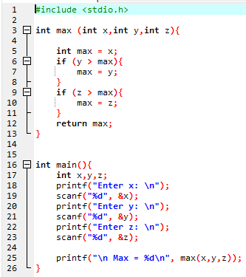

### II.2/ Characteristies:

- Focus on the work to be done (algorithms).

+ Helps beginners can improve their mindset about solving problems.

- Large program is divided into subroutines, each of which can be called one or more times in any order.

+It makes it easier for programmers to address problems since faults in each sub-program may be readily fixed.

- Most functions use common data.

- Data in the system is moved from one function to another.

+ Programmers can manage data easily.

- Uses immutable data.(  [Leonila Cordrey](https://popularask.net/author/leonila-cordrey/),2021)

## III/ Problem statement:

### III.1/ Problem:

A math teacher wants to manage grades of a class. The math teacher wants to make a student transcript and submit it to the school. Based on the transcript, the university can classify students according to merit, good, average, ect.

### III.2/ Solution:

The school has expressed an opinion that it wants an application that can help teachers solve this problem easily and effectively. This application will contribute to solving the problems that users face.

# Task 2: Analysis.

## I/ List data types and data structures needed in the problem:

|  |  |  |  |
| --- | --- | --- | --- |
| Variables | Type | Describe | Explain |
| Id | int | ID of student | Can include number.  Eg: 200662,ect. |
| Name | char | Name of student | Used to declare name.  Eg: Bui Huong Linh,ect. |
| Gender | char | Gender of student | Male and female. |
| Age | int | Age of student | Is always an integer.  Eg: 18,19,ect. |
| n | int | Number of student | Is always an interger. |
| Math,chemistry,physics | float | Score of student | Used to declare subjects.  Eg: math,english… |
| Rate | int | Rate of student | Characters  Eg: Good, Excellent…. |
| Avg | float | Avg of student | Used to declare average scores.  Eg: 8.5,6,7,ect. |
| Highest, lowest | float | Highest, lowest of student | Find highest, lowest. |
| op | int | Option of user | Creat e a variable option. |

Code declaring a variable:

Int + Char: used to declare data types like IDs, name…

Float: used to declare subjects, average scores.

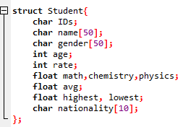



Code: for loop

Use ‘int’ for ‘i’ to traverse data from first element to last element.



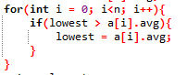



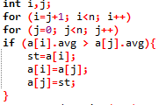

Code: Struct

Used to declare student objects with properties or program manager.

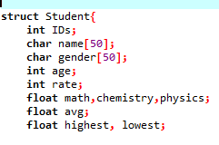

## II/ Switch case statement:

Using switch case statement to create the menu.

Code:

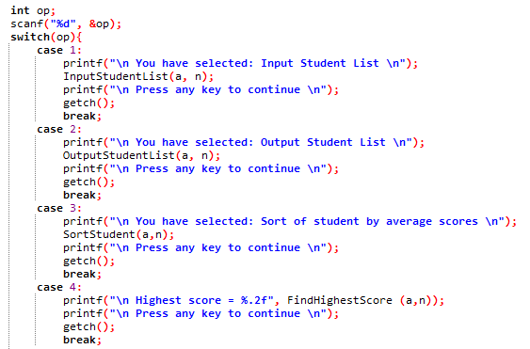

## III/ If-else statement:

Use used to make right and wrong decisions when implementing algorithms.

Code:

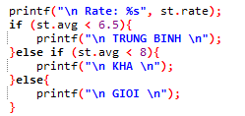

## IV/ Do-while statement:

-Used to perform the previous job and check the following condition.

Code:

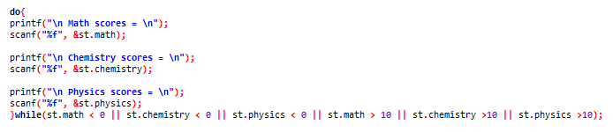

-Used for the user to enter the correct condition of ‘n’.

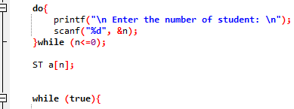

# Task 3: Design

## I/ Use case:

Student Management Program

Input Student List

Output Student List

Find lowest score

Find highest score

Math teacher

Sort score

Exit

## II/ Flowchart:

Start

Input n nnn

False

True

n <= 0?

True

Case 1

False

False

InputStudentList (a[n],n)

Switch op

Output menu

Student a[n]

OutputStudentList (a[n],n)

True

Case 2

False

SortStudent(a[n],n)

True

Case 3

False

Find highest score

True

Case 4

False

Find lowest score

True

Case 5

False

False

Case 0

True

End

Image 3: Function

Explain:

At first, when users want to use the program, they have to enter the number of student.

After entering, the user will have 6 options to choose from.

To choose to enter student information, press 1 and then 'enter'.

When finished, we will press any key to bring up the menu.

After each option the menu will repeat for the user to choose another option.

If the user wants to exit from the menu, they have to choose option 0 then the program will exit.

Start

Name, IDs,gender,age, nationality

Enter math, chemistry,physics

st.math<0 || st.math>10||…

False

Avg=?

True

True

False

Print”Average”



True

Print”Good”

st.avg<8 && st.avg>=6.5

False

Print”Excellent”

End

Image 4: Case 1_ Input Student List

Explain:

At first, enter student information and math,chemistry,physics scores.

Then calculate the average score.

Finally rank ‘Excellent’, ‘Good’, ‘Average’ for students based on the average score.

Start

Read a[],n

i=0

False

True

Student information

End

i<n

OutputSta[i]

i+1

Image 5: Case 2_ Output Student List

Start

student st

int i,j

i=j+1

i< n

False

True

j=0,

j<n

False

True

a[i].avg > a[j].avg

False

True

st=a[i]; a[i]=a[j];

a[j]=st;

OutputStudentList(a,n)

Image 6: Case 3_ Sort of student by average scores

Start

highest = a[1].avg



False

True

highest<a[i].avg

False

True

highest=a[i].avg

End

Image 7: Case 4_ Highest score

Start

lowest = a[1].avg

int i=0,

i<n

False

True

lowest<a[i].avg

False

True

lowest=a[i].avg

End

Image 8: Case 5_ Lowest score

Task 4: Evaluation

I/ Advantages:

+ Can edit or add another problem or algorithm.

+ Easy to use.

+ It allows to move data freely around the system.

+ The program is divided into multiple sub-programs to make it easy for programmers to fulfill the requests that users need.

II/ Disadvantages:

+ Data security is not high.

+ Data is not cared in procedural programming

Task 5: Conclution

Managing student information is a very important job for every school. with an information management software that will help faculty manage students' grades effectively. From there, they can improve the quality of teaching.

Finally, procedural programming plays an important role in the creation of student management applications. I hope this software can help faculty manage students more effectively.

# Bibliography

(2021, 10 22). Retrieved from https://www.learncomputerscienceonline.com/: https://www.learncomputerscienceonline.com/procedural-programming/

Cordrey, L. (2021, 10 22). Retrieved from https://popularask.net: https://popularask.net/which-of-the-following-is-a-main-characteristic-of-procedural-programming-language/?fbclid=IwAR1EOdIZqEnRmfwDA15-V1zZHECGGma92dS13gFxfN8_yiPUP5unXvtaX8M

Grant, A. (2020, 6 10). Retrieved from makeuseof.com: https://www.makeuseof.com/tag/high-level-low-level-programming-languages/

JavaTpoint. (2021, 10 22). Retrieved from javatpoint.com: https://www.javatpoint.com/classification-of-programming-languages

LearnComputerScience. (2021, 10 22). Retrieved from learncomputerscienceonline.com: https://www.learncomputerscienceonline.com/